1. Write a Pandas program to create a scatter plot of the trading
volume prices of Alphabet Inc. stock between two specific dates.
Aim:
To create a scatter plot of the trading volume and closing stock prices of Alphabet Inc. between two specific dates using Pandas and Matplotlib.
Algorithm
- Import the required libraries (pandas and matplotlib.pyplot).
- Read the dataset alphabet_stock_data.csv using pd.read_csv().
- Convert the Date column into datetime format.
- Specify the start date and end date.
- Filter the dataset between the specified dates.
- Create a scatter plot with Volume on the x-axis and Close (stock price) on the y-axis.
- Add chart title, axis labels, and grid.
- Display the scatter plot.
Code:
import pandas as pd
import matplotlib.pyplot as plt

df = pd.read_csv("Csv/Lab6.csv")

df["Date"] = pd.to_datetime(df["Date"])

start_date = "2020-04-01"
end_date = "2020-05-01"

stock = df[(df["Date"] >= start_date) & (df["Date"] <= end_date)]

plt.figure(figsize=(8,5))
plt.scatter(stock["Volume"], stock["Close"])

plt.title("Trading Volume vs Stock Price of Alphabet Inc.")
plt.xlabel("Trading Volume")
plt.ylabel("Closing Stock Price")
plt.grid(True)

plt.show()
Output:
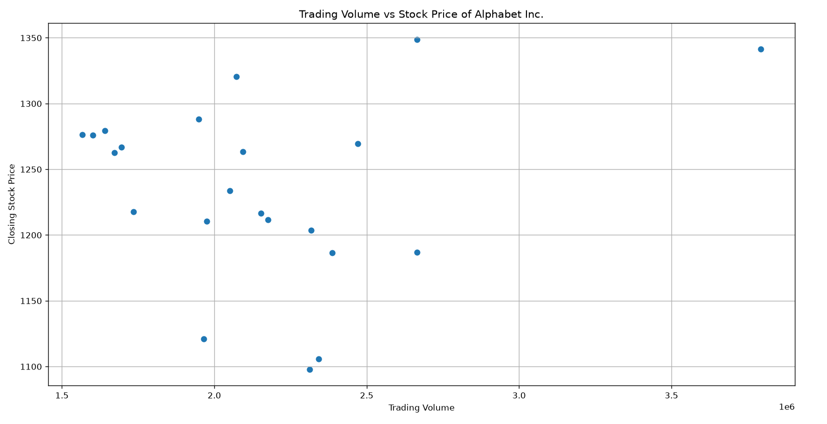

Result:
The scatter plot of trading volume versus closing stock prices of Alphabet Inc. between the specified dates was successfully created using Pandas and Matplotlib. The plot illustrates the relationship between the trading volume and the stock's closing price over the selected period.

2. Write a Pandas program to create a Pivot table and find the maximum and minimum sale value of the items.
Aim:
To create a Pivot Table and find the maximum and minimum sale value of each item using Pandas.
Algorithm
- Import the Pandas library.
- Read the sales_data.csv file using pd.read_csv().
- Create a pivot table using pd.pivot_table().
- Set Item as the index. Use Sale_amt as the values.
- Apply the aggregation functions max and min. Display the pivot table.
Code:
import pandas as pd
df = pd.read_csv("Csv/Lab7.csv")
pivot = pd.pivot_table(
df, index="Item", values="Sale_amt", aggfunc=["max", "min"]
)
print(pivot)

Output:
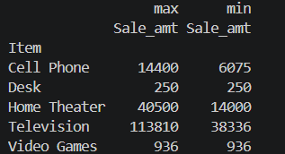

Result:
The pivot table was successfully created, displaying the maximum and minimum sale values for each item in the sales dataset using Pandas.

